**COMMAND SERGEANT MAJOR JOHN K. HERNANDEZ**

State Command Sergeant Major, Oklahoma Army National Guard

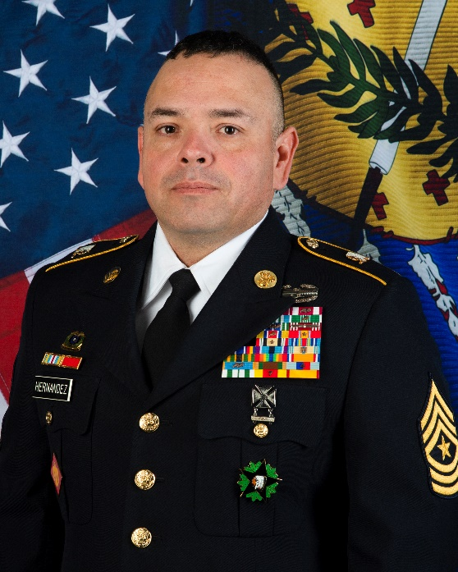 CSM John K. Hernandez enlisted in the Oklahoma Army National Guard while still in high school as a split option trainee. He completed Basic Combat Training in 1993 and attended Advance Individual Training (AIT) the following year at Fort Lee, Virginia, where he qualified as a 76Y, Unit Supply Specialist. He then attended the U.S. Army CBRN school where he acquired the 74D MOS as a Chemical, Biological, Radiological, and Nuclear Specialist (CBRN).

CSM Hernandez has served in the Oklahoma Army National Guard (OKARNG) for his entire career from 1993 to present. His previous assignments include Detachment 1 HHC 45th Infantry Brigade Combat Team (IBCT), HHC 45th IBCT, HHD 345th Combat Sustainment Support Brigade (CSSB), Company A 700 Brigade Support Battalion; Company First Sergeant, 2-245th AVN BN; Company First Sergeant and HHC Joint Force Headquarters (JFHQ) as the State G4 SGM, until his appointment and current assignment as the 15th State Command Sergeant Major of the Oklahoma Army National Guard. His deployments include Afghanistan in 2003, New Orleans/Hurricane Katrina in 2005, Iraq in 2008 as well as numerous State Active-Duty tours in support of Disaster Recovery Missions.

His military education and training include his Initial Entry Training, 2 MOSQ schools, the Primary, Advanced and Senior Leader courses, U.S. Army Sergeants Major Academy (Class 44), U.S. Army Senior Enlisted Joint Professional Military Course, Small Arms Instructor’s Course, Support Operations Course, State Ammunition Managers Course, NATO Ammunition Manager’s Course, and the Training Officer/Operation’s Officer’s Course.

CSM John K Hernandez Graduated from Geary High School in Geary, Oklahoma in 1994, before attending Southwest Kansas University in Winfield, Kansas.

His awards and decorations include the Defense Meritorious Service Medal, Meritorious Service Medal (with two bronze oak leaves), Army Commendation Medal (with one bronze oak leaf), Army Achievement Medal (with four bronze oak leaves), Army Good Conduct Medal (6th Award), Army Reserve Components Achievement Medal (with one bronze oak leaf), National Defense Service Medal (with one bronze service star), Iraq Campaign Medal (with one campaign star), Global War on Terrorism Expeditionary Medal, Global War on Terrorism Service Medal, Humanitarian Service Medal, Armed Forces Reserve Medal (with the 20 Year Device, the “M” Device and Numeral “2”), NCO Professional Development Medal (Numeral “5”), Army Service Ribbon, Overseas Service Ribbon, Joint Meritorious Unit Award, Joint Service Commendation Medal, Oklahoma Distinguished Service Medal, Oklahoma Meritorious Service Medal (with one bronze oak leaf), Oklahoma Commendation Medal, Oklahoma Senior Enlisted Ribbon (with one Silver Diamond), Oklahoma State Active Duty Medal (Numeral “4”), Oklahoma Long Service Medal (25 years), Oklahoma Good Conduct Medal (Numeral “7”), Louisiana State Emergency Service Medal, Combat Action Badge (2nd Award), Driver Mechanic Badge, Marksmen Qualification Badge w/Rifle.

CSM Hernandez is a member of the National Guard Association of Oklahoma (NGAOK), and the Veterans of Foreign Wars, Post 3280, in Clovis, New Mexico.